PRESENDED BY

JAYAPRIYA R -912520104013

INDHUMATHI E -912520104011

SIVATHARSHINI S -912520104029

MANOJ A -912520104303

SURYA M -912520104030

INTELLIGENT PEOPLE AND VECHICLE COUNTING SYSTEM FOR SECRETARIAT

ABSTRACT
This work was carried out to determine the performance of image processing techniques in classifying and counting moving vehicles in video streams of traffic scenes recorded by stationary cameras. The detection and tracking approach is as follows. The moving vehicles are first extracted from the traffic scene by applying the adoptive background subtraction technique. After the background subtraction, using threshold and median filters, isolated image blobs are identified as individual vehicles. Once the blobs are identified, counting and classification of vehicles in a selected region are carried out.
The preliminary results show that the developed system can efficiently and reliably track vehicles when unobstructed view of the traffic scene can be obtained. For optimal camera calibration, an accuracy better than 80% in counting vehicles was observed. The present system performs better with video data in which the vehicles are moving away from the camera compared to the video data in which the vehicles are moving towards the camera. The results obtained through the developed system show that with further improvements the system can be used in real-time to count and classify vehicles on busy traffic routes.

- INTRODUCTION
Traffic management has become an important daily routine in cities today with the exponential growth of traffic on roads. Automatic vehicle detection from traffic scenes and extracting essential parameters related to vehicular traffic can help better management of traffic on busy highways and road intersections. Monitoring traffic flow and estimating traffic parameters can be carried out using sensors [1, 2] as well as through image processing techniques.
With the advances in technology, monitoring traffic through image processing techniques yield a wide
range of traffic parameters such as flow of traffic, speed of vehicles, number of vehicles, classification of vehicles, density of vehicles etc. Since the vehicles can be tracked over a selected segment of a roadway, rather than at a single point, it is possible to measure the “true” density of vehicles for each lane. Image processing techniques can also be applied to traffic video surveillance to detect the vehicles in motion, number plate identification, recognition of obstacles etc. Traffic monitoring through image processing techniques can lead to better control of the flow of traffic as well as to identification of reckless users and speed violators.

In the past, many research studies have been conducted on automated vehicle detection using image processing techniques. The focus of this project was to test the performance in identifying the moving vehicles from a traffic scene and to count and classify vehicles within a given time period.

The following are the required processing steps:
- Converting a video stream to a sequence of single frames.
- Detecting a stable image from a dynamically changing background image.
- Calibration of the camera.
- Identification of vehicles.
- Tracking moving vehicles in each lane.
- Counting vehicles.
- Classifying vehicles.

The paper starts with a brief overview of related work followed by a description of the approach including segmentation, calibration, tracking, and classification. The paper concludes with results and final conclusions.

- RELATED WORK
In reference [3], a system for detection and classification of vehicles is described. It uses a self

adaptive background subtraction technique to separate vehicles from the background. The resulting connected regions are then tracked over a sequence of images using a spatial matching method. The tracked regions are grouped together to form vehicles. Reference [4] also uses adaptive background detection method to identify vehicles. The vehicles are tracked based on contour extraction. Prewitt filter kernel is used for edge detection. The contour linking method used for connecting separated edge parts of the original object into one closed contour. A contour labelling method is used to mark and calculate vehicles within frames. In reference [5], feature based tracking algorithm has been used. Offline camera calibration has been carried out to detect the parameters such as line correspondences for a projective mapping, detection region and multiple fiducially points for camera stabilization. Here, projective transformation is necessary as the features are tracked in world coordinates to exploit known physical constraints on vehicle motion. The transformation is used to calculate distance based measures such as position, velocity and density. In reference [6], adaptive background learning for vehicle detection and spatio-temporal tracking is described. A framework is proposed to analyze the traffic video sequence using unsupervised vehicle detection and spatio-temporal tracking that includes an image/video segmentation method, a background learning/subtraction method and an object tracking algorithm. In reference [7], a system on vehicle detection under day and night illumination is described. Vehicle detection at day time is done by using consecutive three frame subtraction method by detecting moving points. The moving points are classified and labelled as vehicles. Vehicle detection at night time is done by identifying vehicles in terms of pair of headlights. To detect only the objects related headlights, the system perform detection via morphological analysis, by taking into account aspects like shape, size and minimal distance between vehicles. Finally, the verification is based on the correlation between headlights belonging to the same pair. In reference [8], a system for fast vehicle detection with probabilistic feature grouping and its application to vehicle tracking is described. The images were obtained from three cameras installed on a roof of a
30-story building alongside a freeway in order to avoid overlapping of vehicles. System introduces a new vehicle tracking approach based on a model- based 3-D vehicle detection and description algorithm. The proposed algorithm uses a probabilistic “line” feature grouping method to detect vehicles. The tracking is performed based on the zero-mean cross correlation matching technique. System detects vehicles at the entrance area and track the detected vehicles based on their intensity profiles. In reference [9], a system for vehicle detection and tracking is described. This system is fully based on the Block Matching Algorithm (BMA), which is the motion estimation algorithm employed in the MPEG compression standard. BMA partitions the current frame in small, fixed size blocks and matches them in the previous frame in order to estimate displacement of blocks between two successive frames. The detection and tracking approach is as follows. BMA provides motion vectors, which are then regularised using a Vector Median Filter. After the regularisation step, motion vectors are grouped based on their adjacency and similarity, and a set of vehicles is identified per singular frame. Finally, the tracking algorithm establishes the correspondences between the vehicles detected in each frames of the sequence, allowing the estimation of their trajectories as well as the detection of new entries and exits. The tracking algorithm is strongly based on the BMA. It consider the BMA output as the basic tracking information associated with each block and combine this information with the already available block-level tracking as a grouped output in order to achieve the desired result.

- METHEDOLOGY
This section presents the essential steps in project implementation, starting from a video clip of a traffic scene and ending in vehicle classification and counting. The work was carried out with freely available video clips of traffic scenes.
  - Background Detection
To extract stable background image, adaptive background detection method was used [3]. This method uses mean value of pixels within a range of frames to detect the background. If the variance of a given pixel is below a predefined threshold, then the

pixel is considered to be stable. The background image is updated according to the equation given below.

B_{t+1} = B_{t} + S_{t} ×M_{t}

Here, B_{t} is old background image, S_{t} is a mask which varies between 0 and 1 depending on the variance and M_{t} is mean value of pixels.
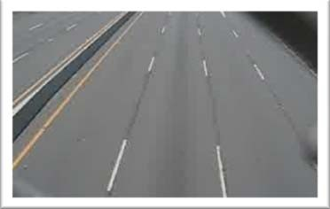

Fig 1: Stable background image
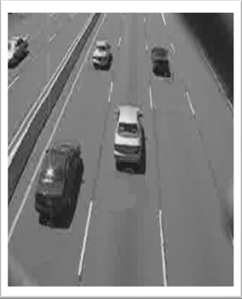

Fig 2: Image under investigation
  - Camera Calibration
Camera calibration plays an important role in the identification process. Camera calibration is carried out to transform the image coordinates to world coordinates [5]. This is essential for the vehicle classification. It is also important if one wishes to extract the speed of the vehicles. In this work following assumptions were taken.
- Road is straight
- Road is flat
- X axis of the road space correspond to the direction perpendicular to the traffic flow and the Y axis is parallel to the traffic flow.
The transformation that has been carried out from the image space to world space is the projection transformation. Assume that the width and the length of the selected area in road space (which are known) are w and h respectively. The equation to
find the projective transformation matrix that maps the image space coordinates (ax,ay; bx,by; cx,cy; dx,dy) to their corresponding road space coordinates is;
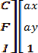
=

To optimize the results of projection transformation matrix, least squares optimization method was used. The projection transformation was used as the initial guess and the best projection matrix was found by using the following objective function [5].
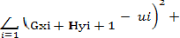

  - Lane Calibration
Since the goal of the project is to identify the vehicles in each lane separately, the lanes must be defined and the centreline of each lane must be identified. User is allowed to select the region of interest by selecting the centre of lanes first and then the starting and ending points on each lane to define the tracking region. The screen space coordinates were first transformed into road space coordinates and then projected onto the lane line.
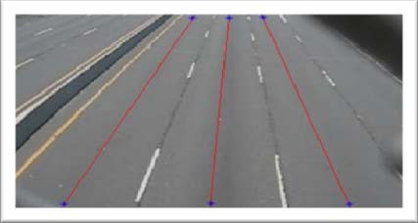
Fig 3: Selected centreline on each lane
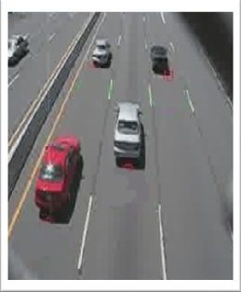
Vehicles were tracked alone the centreline on each lane within the user define tracking area.

Fig 4: Current frame and extracted pixels on lane lines
  - Vehicle Tracking
Numerous techniques have been developed to track moving objects in tracking regions such as tracking points, tracking centroids, tracking rectangles etc. In this work, the bottom coordinates of the identified objects have been used to track moving vehicles in the selected area.
While reading new frame, beginning of the centreline of interest has been examined and if a positive value (here it is 1) is seen, the algorithm considers it as the bottom coordinate of a vehicle. If a positive value was seen in the previous frame and it has now changed, it suggests that the vehicle is in motion in the selected region of interest. By detecting the column vector having top to bottom positive stream of values the vehicle could be detected. Figure 5 illustrates the stated algorithm.

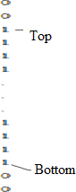

Fig 5: Binary pixel value of column vector of an identified vehicle
By calculating the length of the positive column vector which is the difference between the top and the bottom pixel values of the positive stream of numbers and convert it to the world coordinate space, minimum length of vehicle could be verified. Vehicles that do not satisfy the minimum length requirement were rejected. If a new vehicle is found, it is added to the vehicle array of the lane.
For each vector in the vehicle array, algorithm starts from the last known position of the bottom of the
vector and search forward along the centreline to find the next position of the vector in the next frame. If the search ended up in reaching the end of the region, the vehicle is considered to be exited from the region of interest. This process is repeated for all defined centerlines.
  - Vehicle Classification
Classification is done by categorizing the vehicles into three classes according to the size of the vehicles, namely, large, medium and small. Since it is easy to find the length of vectors, the length has been taken as the parameter to classify vehicles according to the defined sizes. The following table shows the classification used in this work.

Large | Containers, Lorries, Buses
Medium | Cars, Vans, Pickups
Small | Two wheelers, Three wheelers
Table 1: Classification of vehicles
For each new vehicle that enters into the line on the region of interest, the length of vector has been calculated and subjected to the minimum length requirement. Classification was carried out for those vehicles that pass the length requirement.
- RESULTS AND DISCUSSION
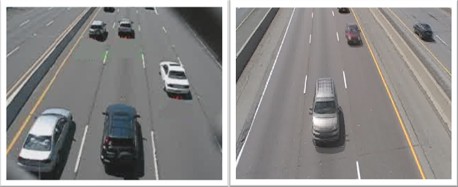
Since the success of the project depend on providing a proper line of site for the camera view, placing the camera on an overhead bridge directly over the flow of traffic route was necessary to minimize the vehicle occlusion. Due to security situation in the country, tests were carried out (to debug the developed algorithms and to evaluate the performance) with freely available video clips on internet, one with vehicles moving away from the camera view and another with vehicles moving towards the camera view (see Figure 6).

Fig 6: Video clips used to test the developed algorithms
The accuracy of the results depends on the camera calibration which takes place to find the projection matrix between the image coordinate and the world coordinate, lane selection and the tracking region. The system has been tested with several camera calibrations to find the optimum results. Figure 7 illustrates results of two camera calibrations for the video clip 1.
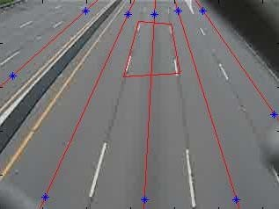
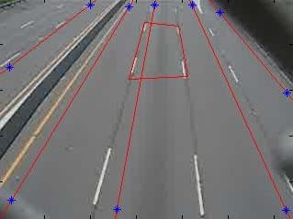

Fig 7: Camera calibrations (1) Optimum calibration
(2) Improper lane selection
In order to reach the desired goal, the video clips were subjected to a series of independent tests that were discussed earlier to carry out vehicle identification, tracking, classification and counting.
For the video clip 1, manually counted results and counting results of the developed system (CCT system) for each lane is given in Table 2. Here, in lane 1, vehicles are moving towards the camera and in lane 2, lane 3, lane 4 and lane 5, vehicles are moving away from the camera view.

Calibration | Lane 1 | Lane 2 | Lane 3 | Lane 4 | Lane 5
Manual | 32 | 36 | 38 | 41 | 4
CCT System | 32 | 37 | 42 | 36 | 12
Table 2: Comparison between actual counting and CCT system counting
It can be seen that except for lanes 4 and 5, other 3 lanes produce results within 10% of the manual counting. As expected, errors increase when the
lanes are skewed in the camera view. The developed system tends to produce errors especially when the vehicles do not travel within the selected lanes and when tall vehicles (such as containers) tend to be in the side lanes often covering two lanes in the camera view.
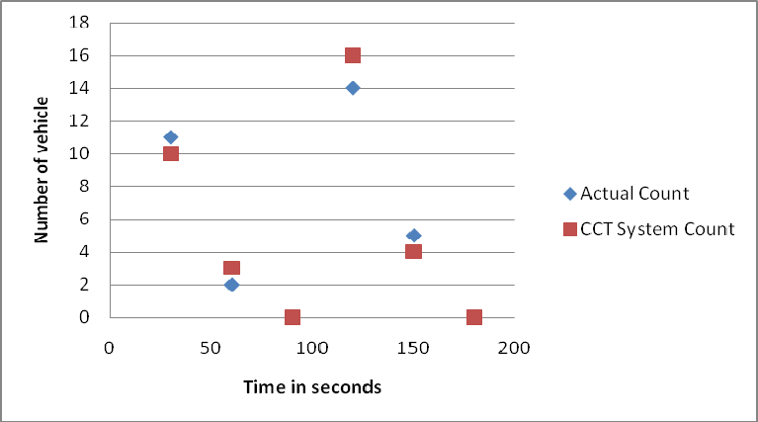
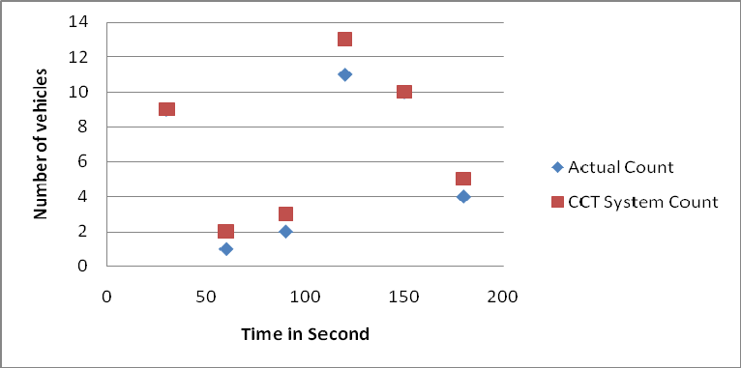

Fig 8: Comparison of counting results for different time intervals for lane 1 and 3
In order to check the performance of the CCT system with the traffic flow rate, data were collected for time intervals of 30 seconds. Figure 8 shows the results obtained for different time intervals for lane 1 and lane 3 for video clip 1.
The classification of identified vehicles was carried out according to the definitions given in Table 1. The main criterion used in the CCT system to classify the vehicles is the length of the vehicles. Figure 9 shows the comparison of vehicle classification between actual classification (visual) and CCT system classification for total (1), large (2), medium (3) and misidentification (4).

- CONCLUSIONS
Preliminary results for developing an automated system for counting and classification of vehicles in motion, based on image processing techniques were presented in this paper. The developed system was able to track vehicles and classify them with a reasonable accuracy. The system is capable of handling video clips of traffic scenes with 15 frames per second in real time.
The results strongly depend on the camera calibration used. If the camera calibration is not optimal, it can easily affect the system performance. When the camera calibration is optimal, developed system showed an accuracy of 93% for lane 1, 97% for lane 2 and 90% for lane 3. As expected, lane 5, which is the furthest lane from camera view and often obstructed due to heavy vehicles showed poor performance in counting.
The results obtained through the developed system show that with further improvements it can be used in real-time to count and classify vehicles on busy traffic routes. Especially, if an obstructed view of the traffic movement can be obtained, the system can perform quite accurately.
- ACKNOWLEDGMENT
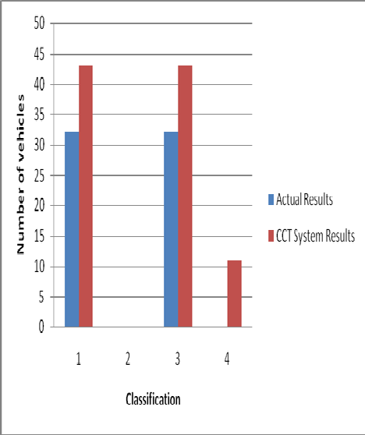
Financial assistance given by the National Science Foundation, Sri Lanka for the research grant number RG/07/E/03 is greatly acknowledged.

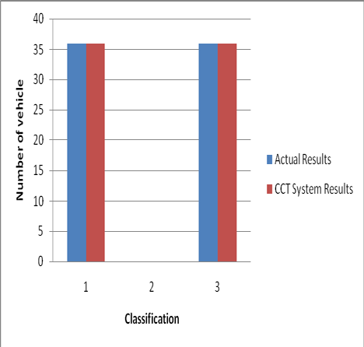
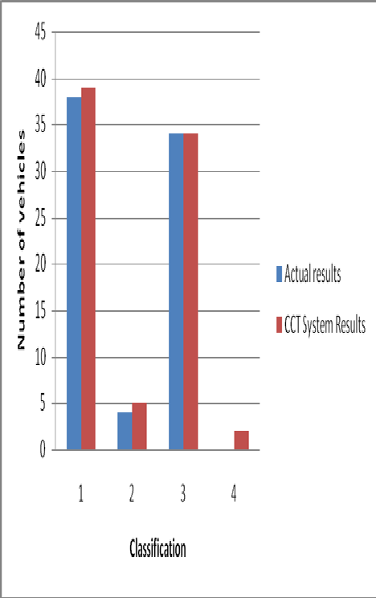
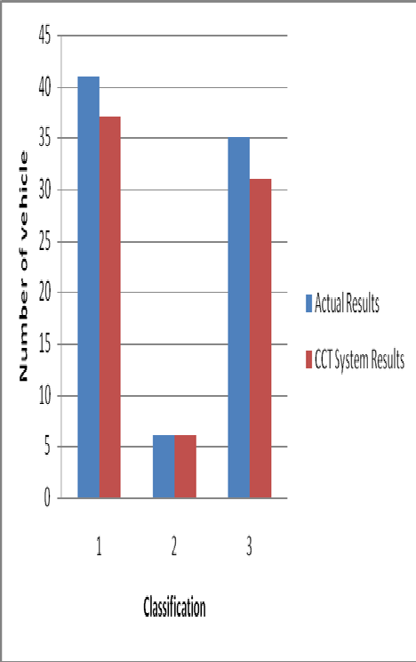

Fig 9: Comparison of classification between actual and CCT system for each lane

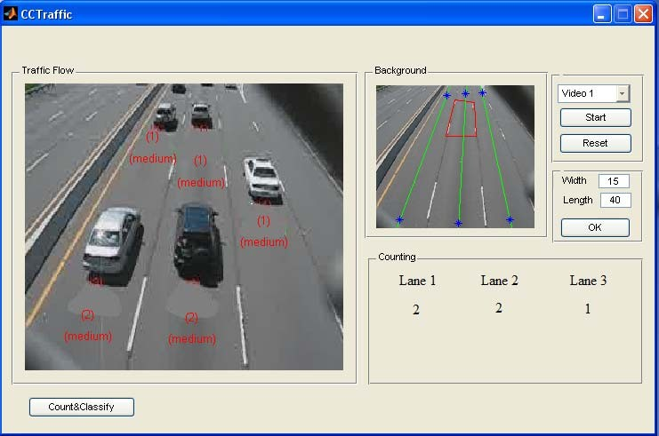

Fig 10: GUI interface of the developed CCT system.

REFERENCES
- R. Chellappa “Vehicle detection and tracking using acoustic and video sensors”, 2004
- Sensor Line, Classax, Traffic Data Acquisition System, Germany, www.sensorline.de
- S. Gupte, “Detection and Classification of Vehicles”, University of Minnesota 2002.
- E. Atkociunas, "Image Processing in Road Traffic Analysis", Vilnius University, 2005
- B. Coifman "A Real-Time Computer Vision System for Vehicle Tracking and Traffic Surveillance" University of California, 1998
- C. Zhang "Adaptive Background Learning for Vehicle Detection and Spatio- TemporalTracking", IEEE, 2003
- R. Cucchiara “Vehicle Detection under Day and Night Illumination" Proc. of ISCS-IIA, Special session on vehicle traffic and surveillance, 1999
- Z.W. Kim "Fast Vehicle Detection with Probabilistic Feature Grouping and its Application to Vehicle Tracking", CiteSeer, 2001
- L. Di Stefano, ”Vehicle Detection and Tracking Using the Block Matching Algorithm", Department of Electronics, Computer Science and Systems (DEIS) University of Bologna, IT

Evaluation of People Counting Systems

T. Schlögl¹, B. Wachmann², W. Kropatsch³, H. Bischof³

¹Advanced Computer Vision, Wohllebengasse 6, A-1040 Vienna, Austria
²Siemens AG Österreich, Programm- und Systementwicklung, Graz, Austria
³Pattern Recognition and Image Processing Group, Vienna Technical University, Favoritenstr.
9/1832, A-1040 Vienna, Austria

This paper addresses the problem of the evaluation of people counting systems. The relation between the real people number and the output of the people counting system is used to motivate the computation of the maximum number of people as a scenario and geometry specific quantity which supports the evaluation of the system output. Based on the camera field-of-view we determine the maximum number of detectable people using a basic people model. The maximum number of people is computed for an overhead camera and for an arbitrary oblique camera orientation which is the typical geometry of standard surveillance applications.

- Introduction
Vision-based real-time people counting comprises all techniques which are able to extract the number of people which are present in an observed area of the real world and which satisfy certain constraints of accuracy and performance. This paper emphasizes the idea that scenario- and geometry specific quantities can rise the accuracy of conventional people counting applications.
Recent research in people counting can be divided into techniques using neural-based crowd estimation ([1], [2], [3]) and methods which are based on blob detection and blob tracking ([4], [5], [6]). Both approaches are rather different from each other. The former employ simple image processing techniques for the extraction of significant features and feed those into a trained neural network to obtain an estimation value of the people in the scene. The accuracy of those systems depends strongly on the training set of the neural network and on the choice of the feature set.
Typical elements of the feature set are the length of the edges and the background area ([1], [2]). People counting by blob tracking is currently an option of systems which are mainly aimed to classify objects and their activities by analyzing their shapes and their trajectories. Those systems

are based on the capability to separate an object from the background. In scenarios where people are crowded, those systems have a poor accuracy since precise object extraction is hardly possible [5].

- Output Accuracy
The output accuracy of a people counting application is evaluated by the relation between the true number of people N_{real} and the mean output of the people counting system N_{out}. Examples for those relations are illustrated in Figure 1. The straight line between the origin and the point (n_{max}, n_{max}) is the ideal case, of course. The diagram illustrates that an overall error in percent is no reasonable measure. Obviously, an error of 30 percent near n_{max} can cause a people number which even exceeds the maximum value. Curve a shows the optimum case of a people counting system which yields always the correct number. Curves b and c show possible variations.
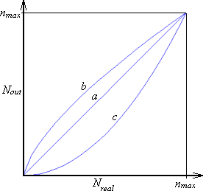
Figure 1: Typical relations between mean output and real people number obtained from people counting systems: Every line represents a relation between the mean output of a people counting system and the real number of people in the viewing area.

Figure 1 incorporates two constraints which can be used for the evaluation of current people counting techniques:
- If there are no people in the viewed area, the people counting system must yield zero.
- For every viewing area, there is a maximum number of people n_{max} who can gather there. The counting system must never exceed this value.

Constraint 1 is trivial and motivated naturally. Most current visual surveillance systems do provide information to human operators concerning the occurence of people within an area. Thereby, the decision whether no person or at least one is present, has a high priority and is of particular importance in security applications.

Constraint 2 includes the requirement that the maximum number of people n_{max} of a scenario must be known. Of course, the number is closely related to the chosen people model. The use of this essential number in people counting applications has not been published so far.

  - Neural-based crowd estimation
Constraint 1 is a critical point for people counting methods based on neural network estimators. They can hardly cope with this constraint since the image processing for feature extraction does not classify edges or blobs at all. Thus, they are sensible to other objects than people, shadows and ambient illumination changes. E. g., in [2], the evaluation of the proposed methods was not performed in respect to this condition. The maximum number of people in the scene is used implicitly in the training set. Good training data are spread over the whole range of possible numbers of people. Thus n_{max} is implicitly used during training, when images with the maximum density are fed into the training algorithm. But generally, there is no proof that n_{max} can not be exceeded by performing the estimation algorithm for images not in the training set.

  - Blob techniques
The capability of blob techniques to fulfill both constraints depends on the reliability and robustness of the realized blob detection and blob classification. Since blobs are analyzed based on their size and their shape [5], blob techniques have the general capability to separate humans from other objects. Thus, it is expectable that they fulfill constraint 1 more likely than neural network estimators. Similarly, constraint 2, the maximum number of people n_{max} must not be exceeded which can be evaluated by counting the blobs and comparing it to the theoretical value.

  - Parametric human body model
The computation of the maximum number assumes the definition of a person model. Figure 2 illustrates the people model which is used in this paper.
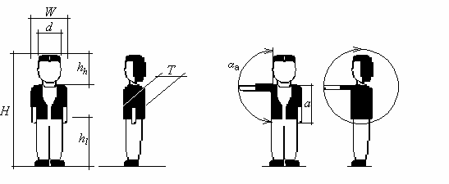
Figure 2: People model: Dimensions used in the computation of n_{max}: H=tallness, W=shoulder width, T=chest depth, D=head diameter, h_{h}=head height, h_{l}=leg length, a=arm length, α_{a}=angle between body and head

- Computation of the maximum number of people
The size of a rectangular area of the video sensor is assumed with S_{W} x S_{B} pixels (the dimension of a pixel element is s_{W} x s_{T}). This area might be the whole sensor area, but can also cover only a smaller part like a bounding box of a blob. First, we do this for the special geometry of an overhead camera and generalize it later to an arbitrary oblique camera orientation.

  - Overhead geometry
This section demonstrates how the minimum number of pixels of the sensor and the maximum number of people can be estimated. All movements of the arms and the legs require more space for a person and reduce the overall number of people. Hence, the motion of arms and legs is neglected.
As Figure 3 illustrates, assuming that there is no sudden vertical movement (e. g. jumping) of a person the actual distance between the closest point of a person and the camera sensor is simply the difference between h and H_{max}. ϑ_{{W,B}} are the viewing angles of the lens of the camera parallel to the side lengths of the sensor. S_{{W,B}} denotes the size of the sensor.

ϑ{W ,B}
= 2 arctan S{W ,B}
2 f

(1)

B_{W} and B_{T} are the projection lengths of the shoulder width W and the chest depth T respectively. Both lengths determine the bounding box of the projected upper body within the image plane. The minimum size of that person, approximated as a rectangle, is evaluated according to the basic projection equations [7]. f denotes the focal length.

object size. f
B =
object distance − f
(2)

If the object distance is much greater than the focal length, the denominator is approximately equal to the object distance.

B = W W
f
h − H
f
(3)

B = T
T
h − H
(4)

Those lengths are converted into pixel dimensions using equations (6) and (7). The use of the maximum value of both side lengths ensures a minimum number of pixels (Equation (8)). In image analysis the sampling interval should be less than or equal to half of the smallest interesting detail in

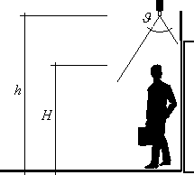
the image in both dimensions [8]. This means that the required number of pixels representing an object must be doubled (in one dimension) due to the sampling theorem.

Figure 3: Camera orientation of an overhead scenario: The geometry is determined by two geometrical parameters, h and ϑ.

smax
= max(sW , s B )
(5)

noverhead
= 2.⎡ BW ⎤

(6)

W ⎢ smax ⎥

noverhead
⎢ ⎥
⎡ B ⎤
T
= 2.

(7)

T ⎢ smax ⎥
⎢ ⎥
The desired value of the maximum number of people in an overhead scenario follows as a ratio of the rectangular sensor area and the minimum area of a single person.

⎡
noverhead = ⎢
⎤
SW .SB ⎥

(8)

max

⎢ noverhead .noverhead ⎥

⎢ W T ⎥

  - Oblique geometry
The variety of the spatial conditions of actual realities in potential locations like waiting areas of supermarkets and banking halls makes it difficult to make any preconsiderations of the components. In contrast to a vertical camera orientation, the distance to the separate persons may vary.
Thus the required resolution is primarily determined by a person observed at the maximum distance L which is determined by the scene geometry. Substituting L instead of h-H into equations
(3) and (4), the resulting value is the estimated maximum.

Equations (5), (6) and (7) allow the computation of the minimum size of a person onto the sensor.

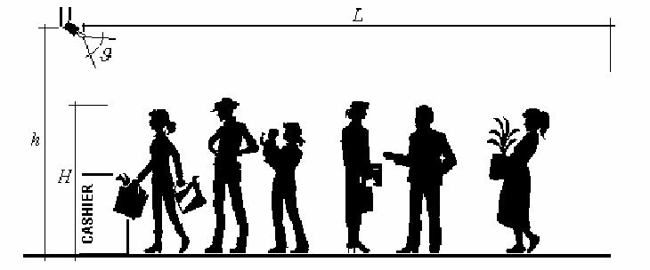
Figure 4: Oblique camera orientation: Monitoring a queue

noblique
⎡
= 2.
W . f ⎤

(9)

W ⎢ smax L ⎥

noblique
⎢
⎡
= 2.
⎥
T . f ⎤

(10)

T ⎢ smax L ⎥
⎢ ⎥
T is the chest depth, s is the size of the video sensor and L is the maximum length of the queue shown in Figure 4. Replacing T_{min} by the corresponding minimum values for shoulder width and tallness equation (9) yields the minimum size of a projected person. Thus, the maximum number of people within the rectangular area of the sensor S_{W} x S_{B} is computed according to equation (11).

⎡
noblique = ⎢
⎤
SW .SB ⎥

(11)

max
⎢ oblique
⎢ n .n
W
T
oblique ⎥
⎥
⎥

- Experimental Results
We implemented a motion detection algorithm based on an adaptive background and threshold model. The application of intensity profile analysis as proposed in [9] allows the detection of stationary and transient objects. The blob information was generated by morphological operations. The parameters of the people model (Figure 2) were used to classify the stationary and transient blobs into two classes: people and other objects. The relevant parameters of the people model were set to H=100...210 cm and W=30...80 cm. All blobs which have the appropriate size were counted for the overall people number. No blob analysis or correlation between successive frames was done.

This algorithm was applied to two test videos recorded at an oblique camera geometry in a railway station in Vienna. Figures 5a and 5b show two snapshots where the people density is very low and where constraint 1 is evaluated. The abscissa indicates the frame number of the video sequence

while the ordinate gives the overall people number. Figure 5b illustrates that the person in the lower part of the scene does not fulfill the people model and is therefore not detected as human.

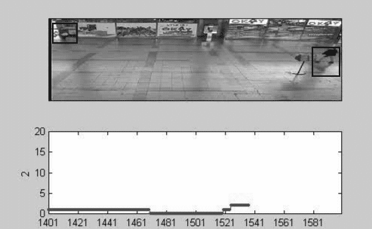
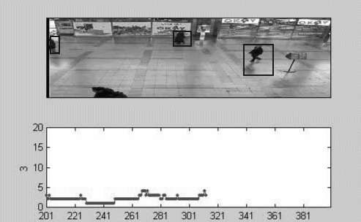
Figure 5: Detection of people at low densities: (a) Proper detection of two people, (b) critical case where a person in the foreground is not detected properly

Figure 6 shows the application of the algorithm for higher people densities. The bounding boxes illustrate that the algorithm is not able to distinguish people which occlude each other properly. This is not surprising since no blob analysis was performed. The maximum number of people which can be found within such a blob is computed using equation (11). This value is used as a reference value for an estimator of the people number in this blob.
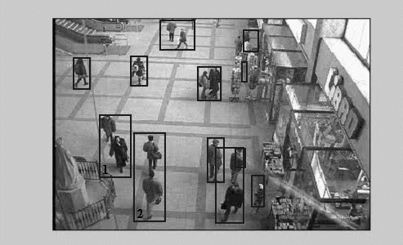

Figure 6: Blob detection: The sizes of the bounding boxes of blobs 1 and 2 indicate that more than a single person is contained. Equation (11) allows the computation of the maximum number of people for every single blob.

The camera was calibrated by measuring the bounding box in pixels of an object of known dimension placed at the nearest and farest point of the viewing area. The computation of the size of each detected blob S_{W} x S_{B} was interpolated linearly. Similarly, length L of equations (9) and (10) was linearly approximated from the total depth of the viewing area.

- Conclusions
We described how the two current approaches of automatic people counting algorithm deal with our suggested constraints for the evaluation process. Based on the camera field-of-view and a basic people model, it was shown how the maximum number of detectable people is computed for overhead and oblique camera orientations.

- References
- C. S. Regazzoni, A. Tesei, „Distributed data fusion for real-time crowding estimation“, Signal Processing 53, pp. 47-63, 1996.

- S.-Y. Cho, T. W. S. Chow, C.-T. Leung, „A Neural-Based Crowd Estimation by Hybrid Global Learning Algorithm“, IEEE Transactions on Systems, Man and Cybernetics – Part B: Cybernetics, Vol. 29, No. 4, August 1999, pp. 535-541.

- T. W. S. Chow, J. Y.-F. Yam, S.-Y. Cho, „Fast training algorithm for feedforward neural networks: application to crowd estimation at underground stations“, Artificial Intelligence in Engineering, Vol. 13, pp. 301-307, 1999.

- V. Kettnaker, R. Zabih, „Counting People from Multiple Cameras“, IEEE International Conference on Multimedia Computing and Systems, Vol. 2, pp. 267-271, 1999.

- I. Haritaoglu, D. Harwood, L. S. Davis, „W⁴: Real-Time Surveillance of People and Their Activities“, IEEE Transactions on Pattern Analysis and Machine Intelligence, Vol. 22, No.8, August 2000, pp. 809-830.

- R. T. Collins, A. J. Lipton, T. Kanade, H. Fujiyoshi, D. Duggins, Y. Tsin, D. Tolliver, N. Enomoto, O. Hasegawa, P. Burt, L. Wixson, „A System for Video Surveillance and Monitoring“, Carnegie Mellon University, CMU-RI-TR-00-12, 2000.

- F. Matossi, „Bergmann Schaefer: Lehrbuch der Experimentalphysik“, Bd. III, Optik, 4th Edition, Walter de Gruyter & Co., Berlin 1966, p. 75.

- M. Sonka, V. Hlavac, R. Boyle, „Image Processing, Analysis and Machine Vision“, 1st Edition, Chapman & Hall Computing, 1993.

- R. T. Collins, A. J. Lipton, T. Kanade, H. Fujiyoshi, D. Duggins, Y. Tsin, D.Tolliver, N. Enomoto, O. Hasegawa, P. Burt, L. Wixson, „A System for Video Surveillance and Monitoring“, Carnegie Mellon University, CMU-RI-TR-00-12,

View publication stats

